**Create/Update Provider**



**Anthem Provider Management**

1. Add/Update Provider:

**Add/Update Provider**

Search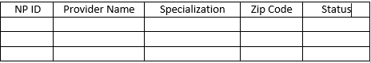

NP ID:

4571280415

NP ID:

4571280415

Provider Name:

John Smith

Physiotherapist

Specialization:

85045

Zip Code:

Active

Status:

Cancel

Add/Update

**Business Rules:**

1. All the fields should have input.
2. NP ID should be = 10 digit Numeric. Neither less nor more.
3. Zip Code should be = 5 digit Numeric. Neither less nor more.
4. User would be restricted from adding more number of digits in NP ID and Zip Code or Alphanumeric.
5. NP ID and Zip Code fields should not go out of focus if digits are less than given value or Alphanumeric
6. Status field should be enabled only in case of Update Provider. For add, it should be Active by default.
7. For Update: Second NP ID and Provider Name should be disabled.
8. On click of Add/Update, Successful case:

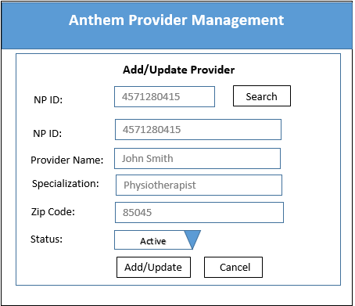

OK

Provider Added/Updated Successfully.

1. On Click of Add with existing NP ID:



Provider ID Already Exists.

OK

1. On Click of Search (for Update) with Non existing NP ID:



OK

Provider ID does not Exist.